

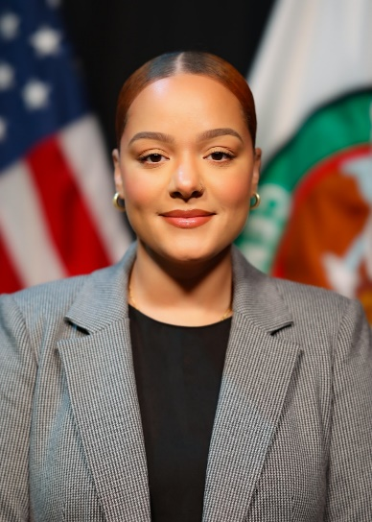

**MAYRA I. HURTADO**

Deputy Chief of Intelligence Systems and Architectures Branch,

Advanced Analytics, Artificial Intelligence, and Machine Learning (A³IM) Division,

United States Central Command (USCENTCOM) Directorate of Intelligence (J2)

Ms. Mayra Hurtado currently serves as the Intelligence Directorate’s Information Technology Requirements Officer, the Battlespace Awareness Joint Capability Area Portfolio Manager, and the Deputy Chief of the Intel Systems and Architectures Branch for A³IM (CCJ28). Ms. Hurtado is a seasoned leader and technology expert responsible for overseeing the strategic development and implementation of advanced systems and architectures critical to the command's mission. Her leadership ensures that USCENTCOM remains at the forefront of modern warfare, leveraging innovative systems to enhance command and control capabilities, cybersecurity, and intelligence gathering in support of national security objectives.

As a former All-Source Intelligence Analyst in the U.S. Army, Ms. Hurtado is a dedicated and astute professional responsible for gathering, analyzing, and disseminating critical intelligence information to support military operations and national security objectives overseas. Her expertise in threat assessment, predictive analysis, and tactical planning contributed significantly to the Army's ability to make informed decisions, safeguard troops, and achieve mission success in complex and dynamic environments.

Prior to her government service, Ms. Hurtado assumed the role of Global Partner Technical Consultant for a commercial organization. She also filled roles as a Cloud Solution Architect, Technical Support Engineer, and a Senior Technical Program Manager. With a deep understanding of the organization’s extensive product portfolio and cloud solutions, Ms. Hurtado collaborated closely with global partners to provide technical guidance and expertise, ensuring the successful deployment and optimization of cutting-edge technologies.

With an A.S. in Computer Science, a B.A. in Intelligence Analysis, and a relentless pursuit of a M.A in International Relations and Global Security, Ms. Hurtado embodies a unique blend of technical prowess and a deep understanding of global affairs. Her academic journey reflects a commitment to bridging the realms of technology and international relations, preparing them for a dynamic career at the intersection of cybersecurity, intelligence, and international diplomacy. Her academic achievements and interdisciplinary approach make Ms. Hurtado a promising future leader in addressing the multifaceted challenges of our interconnected world. Ms. Hurtado resides in Tampa, FL with her daughter.